Stock Market Analysis for General Motors
Company Profile :
General Motors Company
300 Renaissance Center
Detroit, MI 48265
United States
Website: http://www.gm.com
Data Observation Period : Nov'12 - Oct'14

Business Summary :
General Motors Company (GM) designs, manufactures, and markets cars, crossovers, trucks, and automobile parts worldwide. The company markets its vehicles primarily under the Buick, Cadillac, Chevrolet, GMC, Opel, Holden, and Vauxhall brand names, as well as under the Alpheon, Jiefang, Baojun, and Wuling brand names. It also sells cars and trucks to dealers for consumer retail sales, as well as to fleet customers, including daily rental car companies, commercial fleet customers, leasing companies, and governments. In addition, the company offers connected safety, security and mobility solutions, and information technology services. The company, through its subsidiary, General Motors Financial Company, Inc. provides automotive financing services and lease products through GM dealerships in connection with the sale of used and new automobiles that target customers with sub-prime and prime credit bureau scores. The company was founded in 1908 and is based in Detroit, Michigan.
Exploratory Data Analysis :
With exploratory Data analysis (EDA) a statistical method is applied to uncover the underlying structure of a relatively large set of variables. It is a technique within data analysis whose overarching goal is to identify the underlying relationships between measured variables.
In our assignment, to perform exploratory data analysis (EDA)we collect data from publicly available web site ( GM motors, NYSE). We did EDA to observe the data pattern, compare the distribution, find out any missing data or duplicate data and to check violations of statistical assumptions. Performing EDA we have the following finding :
1. Dimensionality of datasets : Measurements made on two variables ( Closing price and
Volume), therefore our datasets can be called Bivariate.
2. Numerical summaries of data :
- Central tendency measured
- Variation or variability measured
3. Graphical summaries of data :
It is said that " A picture is worth a 1,000 words". Based on our data observation we drew
frequency distribution histogram.

Here is the finding of our data analysis :

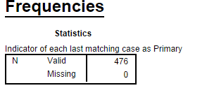
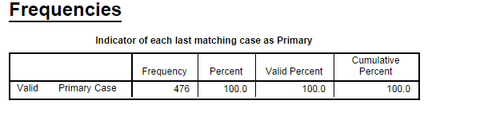

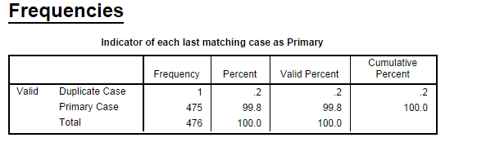
* In actual dataset, there were no missing data. To perform EDA We delete some data and replace with missing values. (Please check Raw data.sav and Clean data.sav respectively)
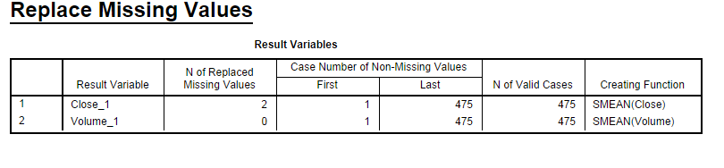
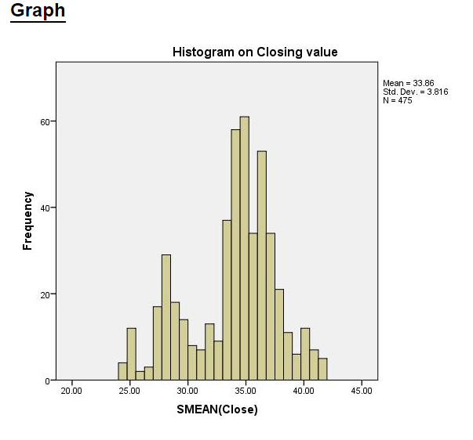

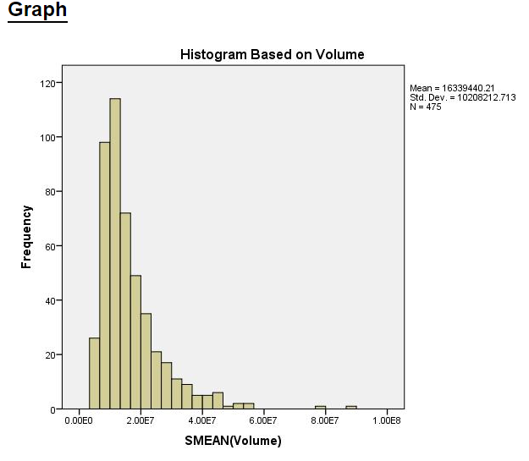

Descriptive Analysis :
- Measures of central tendency ( Mean, Median, Mode)
- Variability (Standard Deviation and variance)

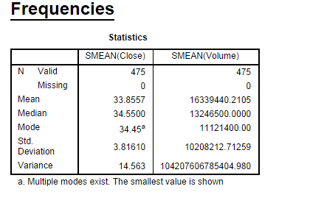
Conclusion :
Using given normalized distribution of closing price and volume dataset, we can get some ideas about the status of General Motors Company in the stock market.. The central tendency parameters including Mean, Median and Mode of closing price are 33.85 , 34.55 and 34.45 respectively. The close values of mean and median shows the somehow normal distribution of closing price. While less value of mode than the others shows the small right skewness in distribution. Greater mean and median values (especially resistance median parameter) than the min value, shows greater closing price. Q1 (first quartile), Q2 and Q3 . This means that only 25% data are less than 1.56 and 75% data are more than 1.56. Inter quartile range is 0.29, which means 50% of data are within the range of 156-1.83. In summary according the statistics of closing price, the company has a good situation.
Therefore both variables shows the good financially condition of General Motor company.

